Microbiology Testing:
- Introduction
The Microbiology Department is committed to ensuring product quality, safety, and compliance with GMP and ISO 13485 standards through reliable microbiological testing and contamination control practices.
- Our Services

Sterility Test

Membrane Filtration Sterility Test
Product is filtered through a sterile membrane that retains microorganisms, followed by incubation in growth media.

Direct Inoculation Sterility Test
The sample is directly added into sterile culture media and incubated to detect microbial growth.

Product Flush Method
Sterile fluid is flushed through a device to recover microorganisms for sterility evaluation.

Immersion Sterility Method
The entire device or implant is submerged in culture media and incubated for contamination detection.

Rapid Sterility Testing
Advanced technologies such as ATP bioluminescence or PCR rapidly detect microbial contamination.

Bacterial Endotoxin Test

Gel Clot BET Method
Endotoxins react with LAL reagent to form a visible gel clot indicating a positive result.

Endpoint Turbidimetric BET
Endotoxin concentration is determined by measuring final turbidity produced in the LAL reaction.

Kinetic Turbidimetric BET
Endotoxin level is quantified by monitoring the rate of turbidity development over time.

Endpoint Chromogenic BET
Endotoxin activates an enzymatic reaction producing measurable color intensity at the endpoint.

Kinetic Chromogenic BET
Endotoxin concentration is determined from the rate of color development during the chromogenic reaction.

Recombinant Factor C (rFC) BET
Recombinant Factor C protein specifically detects endotoxins without using horseshoe crab-derived LAL.

Microbial Limit Test

Membrane Filtration Sterility Test
Product is filtered through a sterile membrane that retains microorganisms, followed by incubation in growth media.

Direct Inoculation Sterility Test
The sample is directly added into sterile culture media and incubated to detect microbial growth.

Product Flush Method
Sterile fluid is flushed through a device to recover microorganisms for sterility evaluation.

Immersion Sterility Method
The entire device or implant is submerged in culture media and incubated for contamination detection.

Rapid Sterility Testing
Advanced technologies such as ATP bioluminescence or PCR rapidly detect microbial contamination.

Gel Clot BET Method
Endotoxins react with LAL reagent to form a visible gel clot indicating a positive result.

Endpoint Turbidimetric BET
Endotoxin concentration is determined by measuring final turbidity produced in the LAL reaction.

Kinetic Turbidimetric BET
Endotoxin level is quantified by monitoring the rate of turbidity development over time.

Endpoint Chromogenic BET
Endotoxin activates an enzymatic reaction producing measurable color intensity at the endpoint.

Kinetic Chromogenic BET
Endotoxin concentration is determined from the rate of color development during the chromogenic reaction.

Recombinant Factor C (rFC) BET
Recombinant Factor C protein specifically detects endotoxins without using horseshoe crab-derived LAL.

Specific Pathogen Test:
A microbiological test performed to detect the presence or absence of specified harmful microorganisms in pharmaceutical, medical, or biological products to ensure product safety and compliance.
- Escherichia coli Test
- Salmonella Test
- Staphylococcus aureus Test
- Pseudomonas aeruginosa Test
- Candida albicans Test
- Clostridium Test
- Bile-Tolerant Gram-Negative Bacteria (BTGN) Test
- Enterobacteria Test

- Equipments
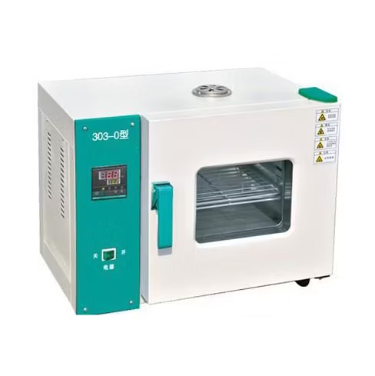
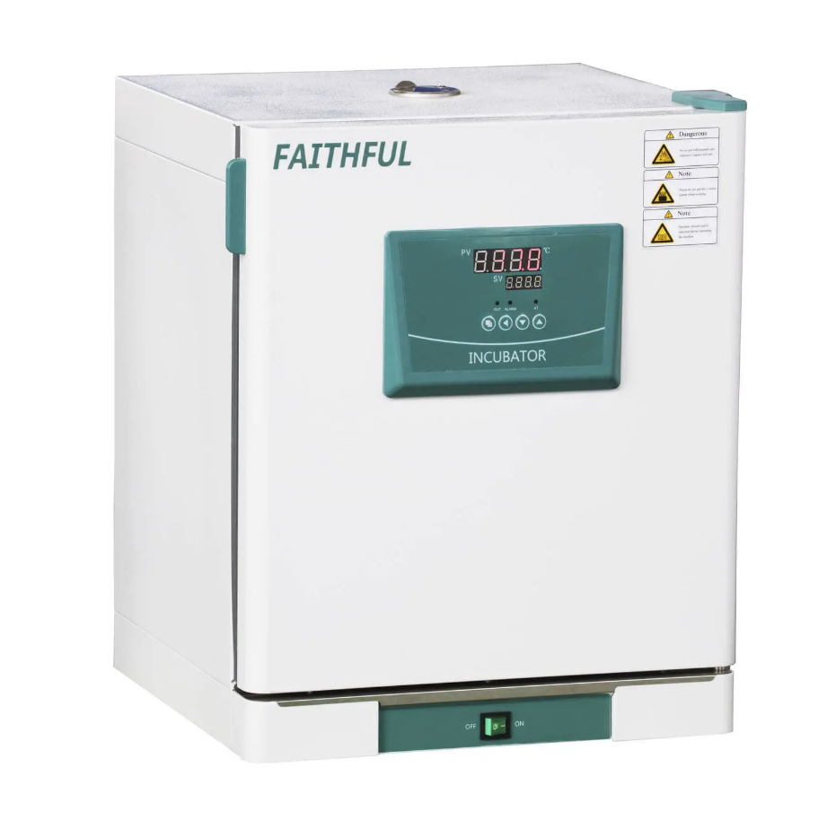
LABORATORY HOT INCUBATOR
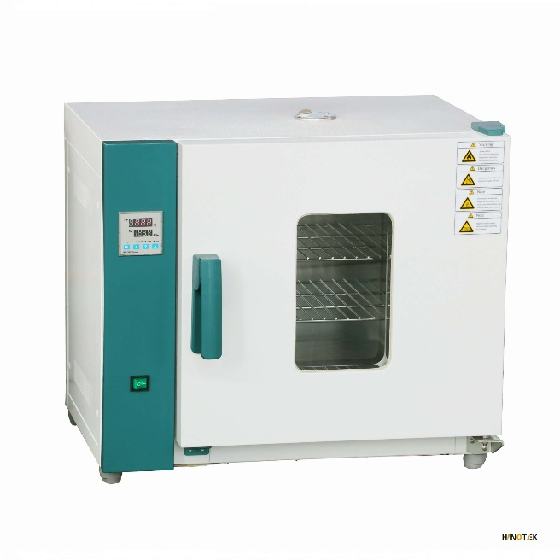
LABORATORY DRYING OVEN
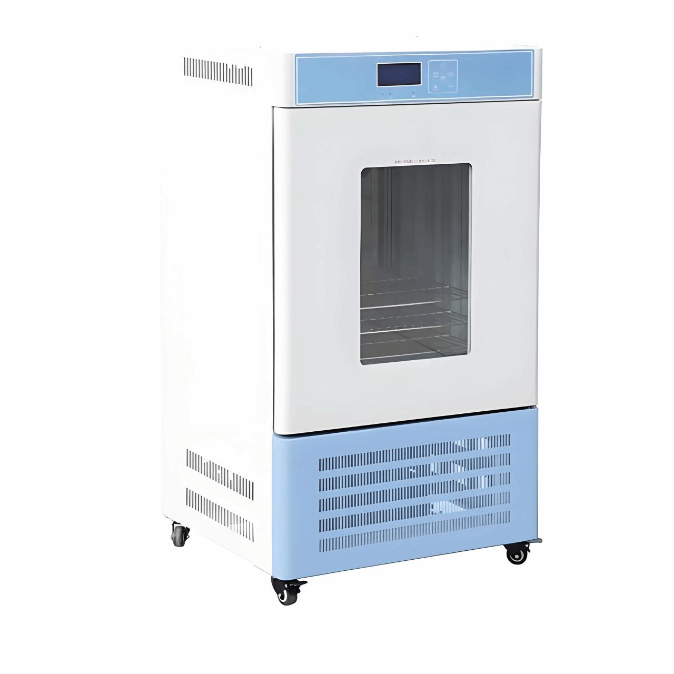
LABORATORY COOL INCUBATOR

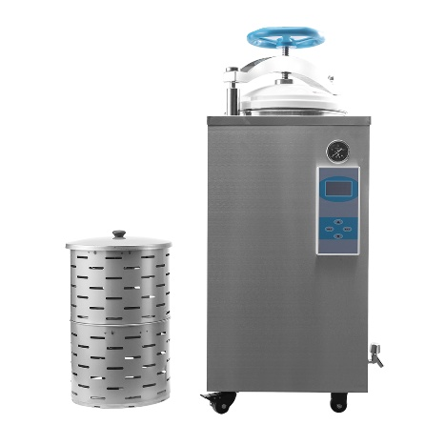
AUTOCLAVE
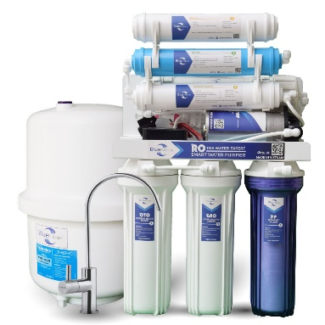

RO FILTRATION PLANT
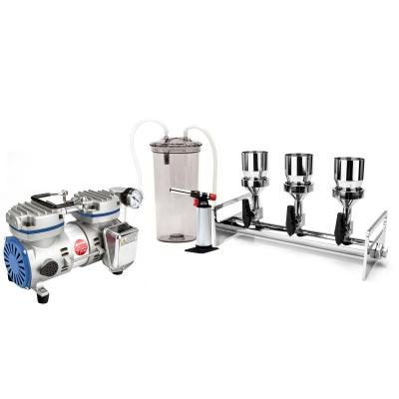
Multi-Position Filtration ASSEMBLY

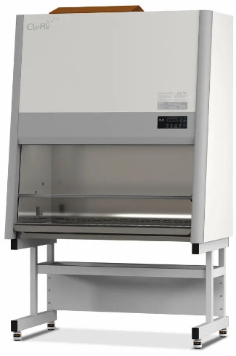
BIO-SAFETY CABINET

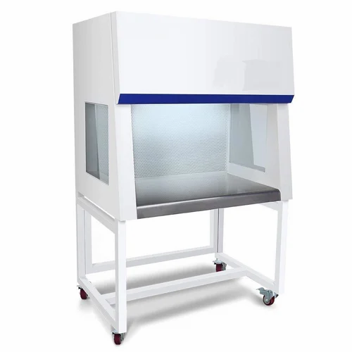

LAMINAR FLOW CABINET

